Are a s Co v e re d: Criminal Patrol Tactics
In-Car / Body Cams
Officer Safety

Roadside Interviews Detecting Deception Consent Searches Salvaging Turn-Downs Arrest Tactics
Basics of Detecting Hidden

Compartments
Contact and Cover
Date: January 6, 2017
0800-1600
Location:
MGCCC/ AMTC Campus
10298 Express Drive
Gulfport, MS 39503
Contact:
Lt. Kevin Hicks
Tuition:
$95.00 Per Student
Checks payable to:
Ed Delmore

Tactics for the Street and Criminal Patrol:
Boots-On-The-Ground Police Work

Including the use of in-car and body worn cameras!

This fast paced one-day course is intended for patrol officers and supervisors who want to become more effective in detecting apprehending and documenting the arrest of criminals including drug users, drug traffickers, fugitives, gang members, and even terrorists.

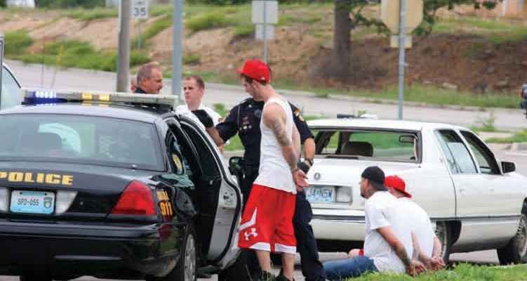

The instructor for this course is Chief Ed Delmore. Delmore has been a police officer more than 34 years and currently serves as the Chief of Police in Gulf Shores, Alabama. For several years he was the working commander of the most successful city criminal interdiction unit in the State of Illinois. He has instructed thousands of officers throughout the United States in criminal patrol tactics and officer survival. He has been an instructor for the Federal Law Enforcement Training Center and the FBI National Academy. He is also the author of several law enforcement articles featured on lawofficer.com, Calibre Press and other law enforcement sites.

Chief Delmore earned a Bachelor of Arts Degree from Western Illinois University and a Master of Arts Degree from Webster University. He is a graduate of the Administrative Officers Course at the University of
Louisville’s Southern Police Institute and of the FBI National Academy.

